Raspberry and Pistachio Semifreddo
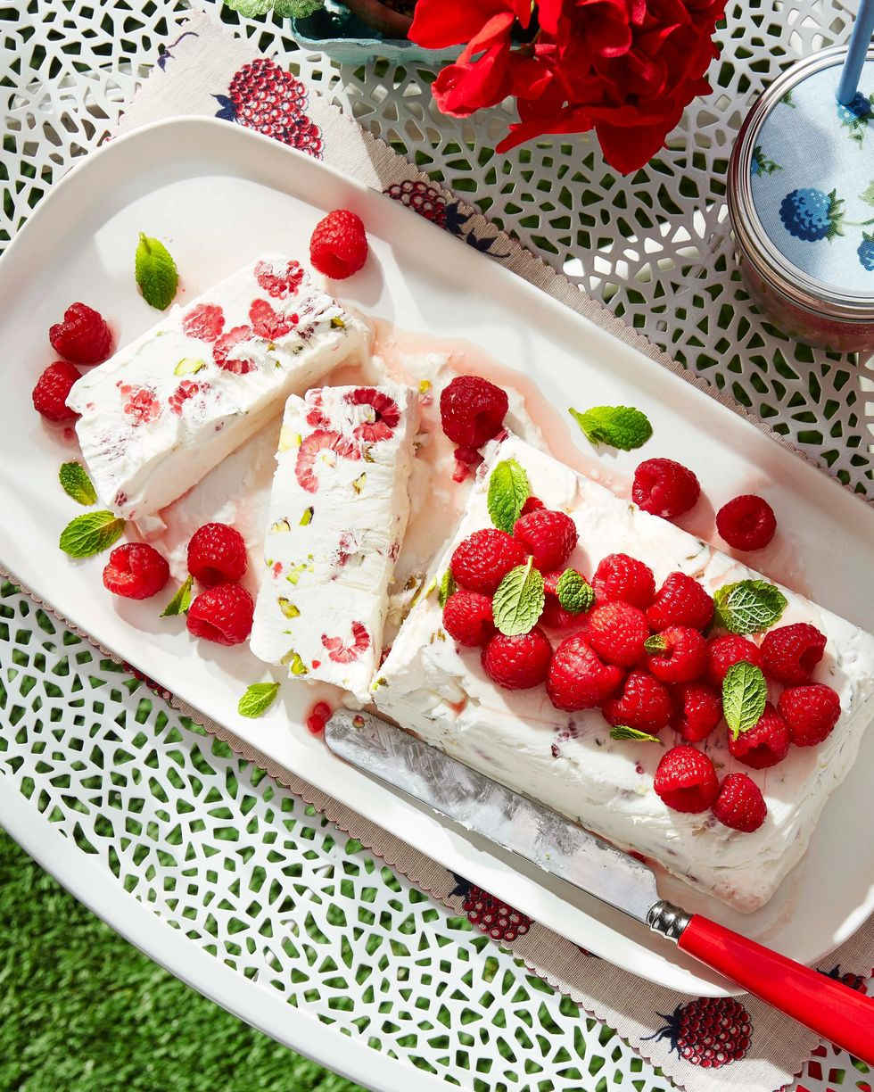
DESCRIPTION:
Use a long serrated knife to cut clean slices. In place of the raspberries, substitute an equal amount of blueberries or chopped strawberries.
INGREDIENTS:
1/4 c. cold sour cream
1/2 c. confectioners’ sugar
1 c. cold heavy cream
1/4 c. pistachios, chopped
2 pt. raspberries, divided
1 tbsp. fresh lemon juice
1 tbsp. pure honey
2 tbsp. fresh mint leaves

INSTRUCTIONS:
Line an 8-by-4-inch loaf pan with plastic wrap, leaving an overhang on all four sides.
Beat sour cream with an electric mixer on medium speed until smooth, 1 minute. Add sugar and beat to combine. Reduce mixer speed to low and gradually beat in heavy cream. Increase speed to medium and beat until stiff peaks form, 2 to 3 minutes.
Fold in pistachios and 1 pint raspberries; transfer to prepared pan. Freeze until set, at least 4 hours or up to 1 week.
Whisk together lemon juice and honey in a bowl until dissolved. Add remaining raspberries and toss to combine. Let sit, tossing occasionally, 18 to 20 minutes. Invert semifreddo onto a platter; discard plastic. Top with raspberries and mint leaves.

